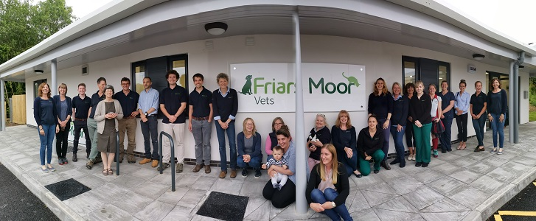
Owing to continued expansion and the future retirement of a vet we are now looking to recruit a new graduate small animal vet. Friars Moor Veterinary Clinic is based in the Blackmore Vale region of north Dorset it is historically a traditional mixed practice founded in 1957. Due to growth and the need to provide more focused services, it has now been divided into specialist SA and LA departments.
Our main and longest standing surgery is located in Sturminster Newton and we have branch surgeries in Shaftesbury and Blandford. Cases requiring more major surgery, investigation and hospitalisation tend to be treated at the Sturminster site but both the Blandford and now Shaftesbury, after its recent move to a new purpose-built surgery, have full operating facilities. We are in the early stages of planning refurbishment of the Sturminster Newton site.
We are a proudly independent practice, plan to remain so and are supported in this by being members of XLVets www.xlvets.co.uk. This is a community of independently owned, progressive veterinary practices that work to achieve the highest standards of veterinary care. Subscribing to XLVets provides us with support such as CPD, Health and Safety and marketing ideas but all decision making, control and ownership remains with the directors of Friars Moor. We aim to give an excellent first opinion service and be the practice of choice in the local area but also be a place where people enjoy coming to work. We do not believe in the corporate pressure of selling and targets. As an independent practice there is always the possibility of longer-term progression to Directorship.
For new graduates we have our own mentoring programme and have taken advantage of the XLVets New Graduate Scheme to help introduce them to the practical challenges of SA general practice. There could be the opportunity to develop by having sole charge at a branch surgery on some days.
Our consultations run between 8.30 to 6.00 during the week and 8.30 to 12.00 on Saturday mornings. We try to keep most consulting sessions to less than a couple of hours without a break and we have 15-minute appointments which has reduced the stress of time pressures. Operating rotas should allow vets to do surgeries on their own cases if they want to.
Consistent with our practice values we run our own out of hours service, but with nearly 7 full time equivalent vets and the rota shared equally between us it is not too bad. During the weeknights we expect to get a call out every other night and probably 5 or 6 over a weekend on average. Most cases are not too serious, and it can be a great way to develop your confidence and skills. Full timers get time off in lieu for OOH work meaning that they work less than a four and a half days per week on average.
We have a good mixture of youth and experience in our team which now totals 9 vets with a combination of areas of clinical interest and expertise. Currently we have one certificate holder in Advanced Veterinary Practice focussing on emergency and critical care. We supported study for this certificate and would be happy to do the same again. We try to deal with as many cases inhouse as we can but there are also good local referral practices if required.
Our nursing team is excellent with 8 qualified nurses and 2 animal care assistants.
A testament to the sort of place we are is the number of vets, nurses, receptionists and admin staff who have worked here for many years.
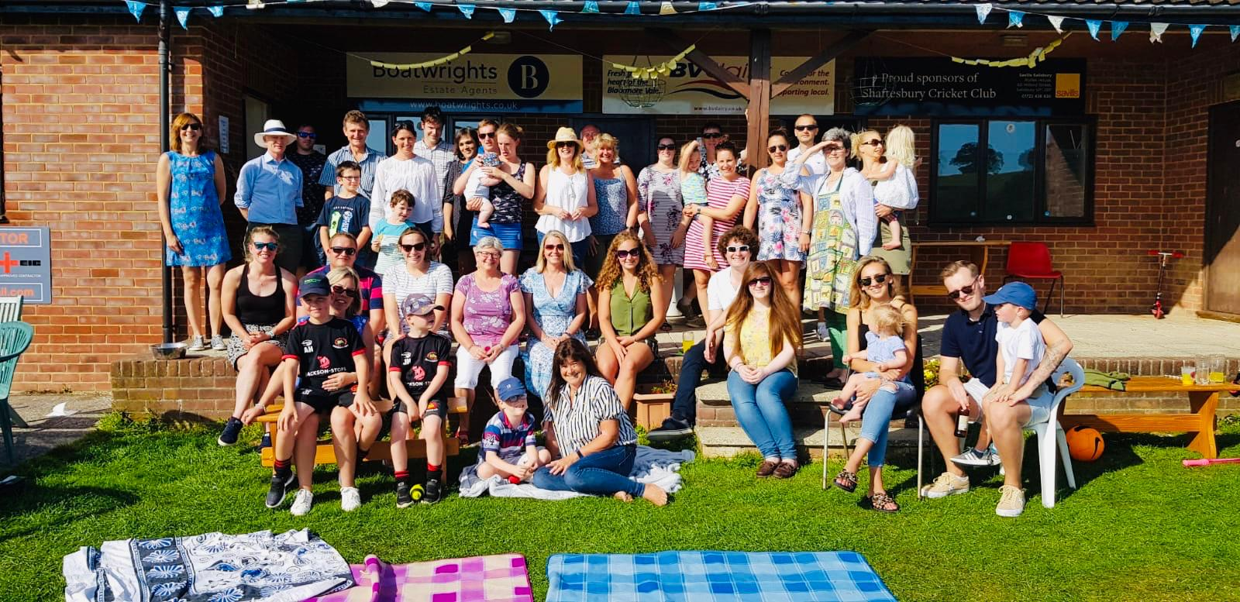
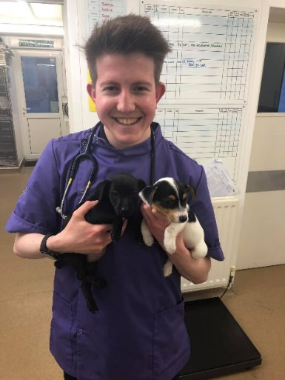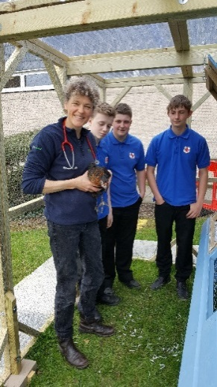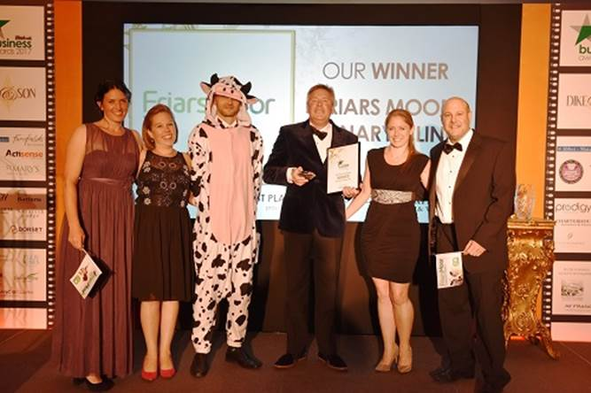

We have a management group called POG (Pet Organising Group) consisting of the directors, senior vets, head nurse and practice manager. Other members of staff are asked to contribute at POG meetings when appropriate and we often get any new vet along to see what goes on. Regular clinical, nurse and receptionist meetings are also held.
We have had outside recognition of the quality of our practice team over the last few years including:
2017 Winner of Blackmore Vale Magazine Awards. Best Place to Work
2018 Justine (our practice manager) won Blackmore Vale Magazine Awards. Best employee
Our support staff were finalists in 2019’s Dorset Business Awards for Team of the Year. We are members of the RCVS Practice Standards Scheme and examples of things an assessor said after our last inspection were “extremely impressed with the efficient manner in which Friars Moor is run allowing all team members to be fully involved”, “clearly a very supportive practice”, “patient care is of a very high standard”, “compassionate, thorough and well trained veterinary and nursing team”, “this is an excellent practice”.
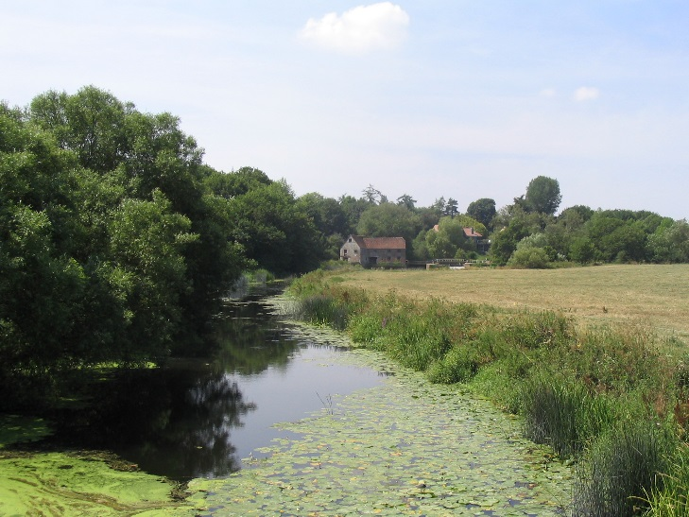
The Blackmore Vale in Dorset is an area of small market towns where we have our surgeries located surrounded by beautiful countryside and villages. Though rural, there is lots going on and our staff seem to be involved in a remarkable variety of societies, sports clubs and other activities outside work. The larger towns of Bournemouth, Dorchester and Salisbury are not a million miles away. The world-famous Jurassic coast lies just south of us for those interested in water sports or simply going to the beach.
We will provide a competitive salary package including RCVS fees, BSAVA membership, funded CPD and private medical insurance.
You can find more information about the practice on our web site www.friarsmoorvets.co.uk and on Facebook.
If this looks like the right job for you and you want to know more or have any specific questions, feel free to phone or email.
Tom Felton Small Animal Director and vet tomfelton@friarsmoorvets.co.uk tel 01258 472314
Justine Turnbull Practice manager justine@friarsmoorvets.co.uk tel 01258 472314
We are very happy for you to speak to any of our current assistants or staff.

In conclusion Friars Moor Vets core values are
TRUST - We earn the trust of our clients.
CARE - We care about what we do and how we do it.
TEAM - We value our team
CLIENT - We work in the best interest of our clients.
COMMUNITY – We are part of the local community.

